**MARKET BASKET ANALYSIS**

**SIMULATED COLES DATA**

**Table of Contents**

Executive Summary 1

Introduction 1

Description of the dataset 2

Original Data 2

Data Preprocessing 2

Consumer Profile 4

Methodology 5

Market Basket Analysis(MBA) 5

Clustering 6

Results 7

Market Basket Analysis(MBA) 7

Clustering 9

Conclusion 11

Future Analysis 11

Appendix 12

Appendix I – Transactional variables 12

Appendix II –Demographical and Socio-Economical Features 13

Appendix III – Basket Items 13

Appendix IV – ReceiptID[Duplicates] 15

Appendix V – Value 16

Appendix VI – pmethod 17

Appendix VII – sex 18

Appendix VIII – homeown 19

Appendix IX – income 20

Appendix X – age 21

Appendix XII – parent 23

Appendix XIII – Pet Owner 23

Appendix XIV – Basket items 24

Appendix XV – Summary for Numerical Variable 24

Appendix XVI – Summary for Categorical Variable 24

Appendix XVII – Income dominating the cluster results 25

Appendix XVIII – Cluster Size 26

Appendix XIX – Number of Children across clusters 26

Appendix XX – Income across clusters 27

Appendix XXI – Value across clusters 28

Appendix XXII – Age across clusters 29

Appendix XXIII – Gender Insights across clusters 30

Appendix XXIV – Payment Methods across clusters 30

Appendix XXV – Parents Insights across clusters 31

Appendix XXVI – Homeown across clusters 31

Appendix XXVII – Pet Owner across clusters 32

Appendix XXVIII – Pet Insight across clusters 32

Appendix XXIX – 3D(Income, age & Value) Scatter plot 33

# **Executive Summary**

This report provides an analysis of the Simulated Coles data which consists of 58,100 observations and 53 variables. The aim of the analysis is to explore questions about which products customers are buying and what kind of customers are shopping at Coles. The answers to these questions can be used to enhance customer experience and/or to maximize profits which can be achieved by improving store layouts, offering discounts or marketing different products together, and determining the best place to shelf the specific products.

After cleaning and preprocessing the data, Clustering analysis and Market Basket analysis have been applied to the data. Clustering analysis results revealed that there 4 groups of customers based on income, age and spending value. These 4 groups are named **Elderly High Spenders, High Spending Youth, Young & Broke and Rich & Wise Youth. These groups are named based on their characteristics of the customers in the groups. Market Basket Analysis results uncovered that there is a high correlation between products like bread, milk & banana and nappies & baby food. Some less obvious product combinations were fish, vegetables & household cleaners and coffee, bread, vegetables, frozen meals & household cleaners.**

**This report also offers a detailed explanation of data cleaning and analytical processes, data mining techniques, analysis outcome, and suggestions for future analysis.**

# **Introduction**

Coles is one of the leading supermarkets in Australia, generally dealing with the provision of everyday goods. The emergence of competitors in the market has meant that the competition has become much fiercer and It is crucial for Coles to take strategic actions to beat the competition. One way to do that is to use the data Coles has been collecting from its customers and analyze data to gain a competitive edge. This report aims to use unsupervised knowledge discovery to find hidden patterns in customers’ transactions and to form customer segments. We’ll be seeking a better understanding of two aspects:

* **Customer Segments**: - What are the different segments or groups and their demographic as well as socio-economic features.
* **Products Patterns**: - Popularity of the products, what kind of products are being bought together, the likelihood of two or more products being purchased together.

By better understanding these two aspects and finding answers to the questions related to these two aspects, Coles would be able to form sophisticated strategies that would help Coles to lead the competition. A better understanding of the customer segments would help Coles create more effective and successful market campaigns and design eye-catchy catalogs of the products whereas better knowledge of product patterns would allow coles to improve in-store layouts and product placements.

# **Description of the dataset**

## Original Data

The original dataset used in this analysis was provided into spreadsheet(.xlsx) format. The spreadsheet consists of:

* 58,100 observations(rows)
* 53 variables(columns)
  + 3 Transcational Variables. *[Appendix I]*
  + 6 Variables representing Demographics and Socio-Economical features of customers. *[Appendix II]*
  + 44 Basket Items. *[Appendix III]*

The table below offers a brief description of each variable(For detailed table go to Appendix)

|  |  |  |
| --- | --- | --- |
| **Variable** | **Type** | **Description** |
| ***ReceiptID*** | Ordinal | Transaction identification number |
| ***Value*** | Continuous | Dollar amount of the transaction |
| ***pmethod*** | Nominal | Payment method: 1 = Cash, 2 = Card, 3 = Eftpos, 4 = Other |
| ***sex*** | Binary | 1 = male, 2 = female |
| ***homeown*** | Nominal | If they own a house: 1 = Yes, 2 = No, 3 = Unknown |
| ***income*** | Continuous | Customer’s income per annum in dollars |
| ***age*** | Discrete | Age last birthday |
| ***PostCode*** | Nominal | Post code of customer’s current address |
| ***nchildren*** | Ordinal/Discrete | Number of children of the customer |
| **Basket Items** | Binary | Supermarket items: 0 = not purchased, 1 = purchased |

***Table 1 Variable Description of Original Data***

## Data Preprocessing

**ReceiptID**:- There are 9 duplicate values of *ReceiptID*. These duplicate values were seen in only ReceiptID and not in other variables. Since this variable is supposed to be a primary key for this data, we will exclude this field from the analysis. ***[Appendix IV]***

**Value**: - There are no missing values in this column. But extreme outliers have been observed which are *$802.0592, $1242.9862 and $1967.6968*. These observations could be explained by saying that these transactions could be the orders for a big party or an occasion. Extreme outlier can cause problems in clustering process, So these values were replaced by the median value($63.58) to retain the original distribution of the variable. ***[Appendix V]***

**nchildren**: - There were 2 missing values initially. The range for this variable is 0-105. The shocking range led me to dig deeper into the data and I found that transactions which had value from 11-105 were also invalid for *pmethod* and *homeown* variable. After sorting the data using either of the variables I have come to know that the increase in these variables is at the same rate and these values are almost levelled. This indicates that whatever caused these invalid values for *nchildren* also cause invalid entried for pmethod and homeown variable. This raises a question of the data quality. ***[Appendix VI]***

**homeown**: - 99 invalid entries(values greater than 3), no missing values were found. ***[Appendix VII]***

**pmethod**: - 97 invalid entried(values greater than 4), no missing values were found. ***[Appendix VIII]***

The same course of action was taken for variables *nchildren*, *homeown* and *pmethod*, which was to remove all the transactions with the invalid entries as these transactions represent only 0.17% of the total transactions. After removing the invalid transactions, there were still 2 missing values in *nchildren* which were replaced by the median value which is 1.

**income**: - One missing value and one extreme outlier($650235.25), both values were replaced by the median income($70169.026563) to retain the distribution. There was break in income from $120,000 to $130,000 and then there were many observations which income greater than $130,000 which is not usual but all the other entries are valid so I let it be. ***[Appendix IX]***

**age**: - has one missing value which was replaced with the median age of 37 years. There are several records having float values(with decimal places), since I didn’t know how the data was collected I left the values as they were. The range for age is from 10-95 years. On closely exploring the age variable I have found out that lot of young customers(below 16 years) were listed as house owerns, having multiple children and earning high salaries which does not make any sense so I decided to remove all the entries where age of the customer is less than 16. Due to what I have found out about the variable, I warn the readers that the analysis result could be biased or inaccurate given the bad data quality. ***[Appendix X]***

**PostCode**: - 9792 missing values which represent 17% of the data because of that I decided to keep the records as I am not going to exclude *PostCode* from analysis. There are plenty of invalid entries (alphanumeric values) for *PostCodes*.

**Basket Items**: - *PizzaBase*, *milk*, *confectionary*, and *cannedveg* have 1 missing value, *cereal* has 9 and *Fruitjuice* has 10 missing values. *fruit* has 10 invalid entries, two of which were “o” and the others were values greater than 1. The “o” were probably intended to be zeros, so I replaced the values by 0. The rest of the values(>1) were replaced by 1 as it seemed that the error was due to customers purchasing more than 1 quantity of the item. All other missing values were replaced by 0(the most frequent category). ***[Appendix XIV]***

**Variable Created**

**Pet Owner**: - It was created using variables ‘*dog* *food’* and ‘*cat* *food’* to check how many customers own a pet(s) or not.

**parent**: - This variable was created using variable *nchildren* to discover how many customers are parent.

**NOTE**: - I have created new variable for I have created new variables for categorical data(*sex*, *pmethod*, *nchildren*) just for visualization purpose named *sex*_*processed*, *pmethod*_*processed* and *nchildren*_*processed*. So, after all the data preprocessing there are 57,622 rows and 59 columns in the data. ***[Find visualizations for all necessary variables in the appendix]***

## Consumer Profile

Coles customers’ age range from 16 to 95 years averaging around 39 years. The median annual income is $70,170 with 50% of the customers earning between $65,623 and $75,324. There seems to be a gap between income $120,000 and $130,000 with no apparent reason that justifies it.

At least 60% of the customers are female and they spend median amount of $68.17 per transaction, where males spend $56.72 which indicates that generally women take care of the grocery. The median amount spent by all the customers on is around $63.28.

At least 73% of the customers own a house and they spend 16% less median value than custoemers who own a house and 70% of the customers are parents. Generally customers have 1, 2 or 3 children. There are very few occurrences where customers have more than 3 children.

The payment preferences of the customers are(in descending order): Card 42.49%, EFTPOS 30.5%, Cash 14.4%.

**FUN FACT**: - Around 31%(18,076) of the total customers own a pet(s). Out of those 18,076 customers 53% own a dog(s), 37% own a cat(s) and 10% own both a dog(s) and a cat(s).

The **MOST** purchased items were: The **LEAST** purchased items were

1. Bread, 82.85% of the times 1. KitKat, 1.64% of the times

2. Milk, 81.34% of the times 2. energydrink, 1.85% of the times

3. Cereal, 76.35% of the times 3. frozen fish, 2.94% of the times

4. Banana, 76.18% of the times 4. TeaTowel, 3.70% of the times

5. Lettuce, 74.31% of the times 5. Icecream, 4.36% of the times

Find visualization related to basket items in *Appendix XIV*. All other visualizations and summary statistics can be found in ***Appendix***.

# **Methodology**

## Market Basket Analysis(MBA)

The purpose of MBA is to discover patterns in customer purchases that could be useful to the retailer and help determine the correct stock levels, product placements on shelves, catalogue design and strategy for the next marketing campaign and target audience. The most useful weapon in the data mining arsenal is generating association rules using MBA when it comes to Transactional data.

Apriori algorithm is widely used to generate association rules. These rules are generated on the basis of how frequent a product is in the data. I used package *mlxtend* in Python to generate rules. The algorithm uses following metrics and terminology:

* **Rules**: - Given a rule "A -> C", A stands for antecedent(Item A) and C(Item C) stands for consequent.
* **Antecedent Support**: - It computes the proportion of transactions that contain the antecedent A.
* **Consequent Support**: - It computes the support for the itemset of the consequent C.
* **Support**: - Support is used to measure the frequency (often interpreted as significance or importance) of an itemset in a database(all the transactions here).
* support(A -> C) = support(A ∪ C)
* The 'support' metric then computes the support of the combined itemset A ∪ C -- '**'support' depends on 'antecedent support' and 'consequent support' via min('antecedent support', 'consequent support')**
* **Frequent Itemset**: - We refer to an itemset as a "frequent itemset" if you support is larger than a specified minimum-support threshold. Due to the downward closure property, all subsets of a frequent itemset are also frequent.
* **Confidence**: - The confidence of a rule A -> C is the probability of seeing the consequent in a transaction given that it also contains the antecedent.
* confidence(A -> C) = support(A -> C) / support(A)
* **This metric is not symmetric or directed; for instance, the confidence for A -> C is different than the confidence for C -> A.** The confidence is 1 (maximal) for a rule A->C if the consequent and antecedent always occur together.
* **Lift**: - The lift metric is commonly used to measure how much more often the antecedent and consequent of a rule A -> C occur together than we would expect if they were statistically independent.
* lift(A -> C) = confidence(A -> C) / support(C)

Before running the algorithm, we need to set threshold parameters. We set minimum antecedent support at 10%, which means that the antecedent product(or product set) must have occurred in the data at least 10% of the times. 10% threshold support seems rather low but since the data set is large (57,622 transactions), the probability of occurrence is relatively small. *[Threshold for lift has been set to 1]*

## Clustering

Cluster analysis or clustering is the task of grouping a set of objects in such a way that objects in the same group (called a cluster) are more similar (in some sense) to each other than to those in other groups (clusters). It is an unsupervised classification technique, which means that classes are not predefined. I inted to uncover the customer segmentation based on their features like spending habits, income and age that’s why I chose clustering to begin with.

There are many clustering techniques: Hierarchical Clustering which decompose the data using either divisive or agglomerative strategies. Generally they are prefferd as they don’t require the number of clusters o be specified in advance. However our data set is too big for such algorithm and it would take significant amount of time. So, I chose KMeans for clustering as it would be much more efficient. There are also many ways to carry out KMeans depending upon which distance metric we use to create clusters but here I’ll be using Euclidean distance.

The KMeans clustering method is a partitioning algorithm. Once we specify the number of clusters in the data set, algorithm will randomly select a centroid for each cluster(generally points from data set), find the closest data points and assign them to the centroid, recalculate the centroid(be averaging all the data points in the cluster). The above steps are repeated until there is no change in the cetroids. There are many limitation of this KMeans, one of them is this can only be applied on the continuos variable. I wanted to group customers based on age, spending and income and all the variables are continuous so we can perform KMeans easily. The another problem with Kmeans is that the centroids are sensitive to magnitude of the values as they are calculated by taking a mean of the data points. So before I apply Kmeans I will standardize variables(z-scores) as income, age and Value are not on equal footing and this can cause inefficient results sometimes. For example for 4 clusters, variable income has larger value, it is going to dominate the cluster results and clusters are gonna form based on different values of income***[Appendix XVII]***. As we can see there are 4 visible groups in the income, because income has larger values compared to other variables.

**How many clusters?**: - We can determine the optimal number of clusters by plotting graph of number of clusters versus the withing sum of squares. Lesser the withing sum of square better the clusters are.

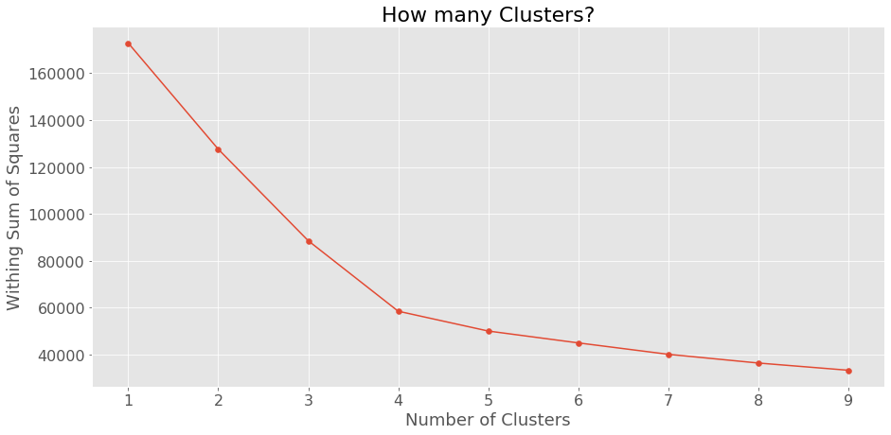

**Figure 1 – How many clusters?**

Based on the graph on the left side, there is an obvious elbow at 4 clusters. Here we can’t choose 9 clusters even though the within sum of square is the least for it. We have to choose optimal number of clusters, choosing 9 clusters would make interpretation of the clusters difficult. So, I am choosing 4 clusters as it has balanced within sum of squares.

# **Results**

## Market Basket Analysis(MBA)

There were plethora of association rules generated by the Apriori algorithm. I have divided them into 3 groups: Rules with high support, high confidence and high lift.

**HIGH SUPPORT**

|  |  |  |  |  |  |
| --- | --- | --- | --- | --- | --- |
| **Rule** | **Antecendent** | **Consequent** | **Support ↑** | **Confidence** | **Lift** |
| S1 | bread | cereal | 63.90 | 77.13 | 1.01 |
| S2 | banana | bread | 63.87 | 83.85 | 1.01 |
| S3 | cereal | milk | 62.22 | 81.49 | 1.00 |
| S4 | milk | banana | 62.08 | 76.32 | 1.00 |

***Table 2 Rules With High Support***

Bread & Cereal is the most popular combination of products being bought 63.9% of the time. The second and third most popular combinations of product are Bread & Banana(63.8%) and Milk and Cereal(62.2%). These rules are also called most obvious rules as they are most common items bought by the customers. These rules don’t have much value to us.

**NOTE: -**  *Due to high frequency of some products like bread, milk, cereal, banana and lettuce, they were appearing in almost all the rules. I have decide to drop these 5 items so that I can discover relationship between products which are not obvious.*

**HIGH CONFIDENCE**

|  |  |  |  |  |  |
| --- | --- | --- | --- | --- | --- |
| **Rule** | **Antecendent** | **Consequent** | **Support** | **Confidence↑** | **Lift** |
| C1 | (Napies, TomatoSauce) | (Baby Food) | 10.33 | 95.81 | 1.98 |
| C2 | (Olive Oil, Napies) | (Baby Food) | 10.72 | 94.26 | 1.95 |
| C3 | (coffee, householCleaners, frozenmeal) | (vegetables) | 13.75 | 93.98 | 1.61 |
| C4 | (coffee,  TomatoSauce, householCleaners) | (Vegetables) | 62.08 | 76.32 | 1.00 |

***Table 3 Rules With High Confidence***

The probabilities that Customers will buy Baby Food are 95.8% and 94.2% when they buy (Napies & TomatoSauce) and (Napies and Olive Oil). Similarly, probabilities that customers will buy Vegetables are 93.9% and 93.5% when they buy (householCleaners, frozenmeal & coffee) and (householCleaners, TomatoSauce & coffee). However, these combinations of products are less likely to occur(10% - 14%).

Rules C1 and C2 are rather strong - they both have high lift and confidence indicating that customers who buy antecedent products are 1.9 times more likely to buy the consequent products. Rules C3 and C4 are less obvious relationships. Although, the lift for these rules is low, coles could probably increase sales by advertising/marketing householCleaners, coffee, frozenmeal, TomatoSauce with Vegetables(if possible stock them near).

**HIGH LIFT**

|  |  |  |  |  |  |
| --- | --- | --- | --- | --- | --- |
| **Rule** | **Antecendent** | **Consequent** | **Support** | **Confidence** | **Lift↑** |
| L1 | (fish, vegetables) | (householCleaners) | 10.82 | 85.77 | 2.24 |
| L2 | (fruit, fish) | (householCleaners) | 10.32 | 79.06 | 2.07 |
| L3 | (Napies, TomatoSauce) | (Baby Food) | 10.33 | 95.82 | 1.98 |
| L4 | (Napies, Olive Oil) | (Baby Food) | 10.72 | 94.23 | 1.95 |
| L5 | (Napies, Chocolate) | (Baby Food) | 10.69 | 92.94 | 1.92 |
| L6 | (Napies, fruit) | (Baby Food) | 14.94 | 92.85 | 1.92 |

***Table 4 Rules With High Lift***

Rule L1 - As we can see, Customers who bought Vegetables & Fish are 2.2 times more likely to buy householCleaner. These items were bought together for like 10% of the time but 85% of the customers who bought Vegetables & Fish also bought householCleaners. Customers who bought fish and fruit together are 2 times more likely to but householCleaners with low support and high confidence. These products need to be marketed together or perhaps give discount on householCleaner to the customer who buys Vegetable, Fish or Fruit.

**Obvious rules – L5 & L6**

Parents often buy fruit and chocolates for their young ones. Rules L3 & L4 are not as obvious as L5 & L6 but Coles can stil use them. By looking at the rules with Baby Food in consequent(with low support), We can give discounts on Baby Food if customers by (Napies & fruit), (Napies, Chocolate), (Napies, Olive Oil) or (Napies & TomatoSauce) to increase the support of these transactions[If it is not possible to carry out marketing for all the combinations, what Coles can do is it should make sure that these products are as close as possible to Baby Food].

## Clustering

After running KMeans on standardized variables z_income, z_value and z_age we get following clusters.

|  |  |  |  |  |  |  |
| --- | --- | --- | --- | --- | --- | --- |
| **Cluster** | **Size** | **Median**  **Income** | **Median**  **Value** | **Median**  **Age** | **Homeowners**  **(Yes / No)\*** | **Sex**  **(F / M)** |
| 1 | 7.7% | $66,706 | $103 | 72 | 43% / 56% | 70% / 30% |
| 2 | 27.9% | $69,348 | $134 | 35 | 72% / 25% | 63% / 37% |
| 3 | 54.8% | $69,434 | $37 | 38 | 76% / 22% | 57% / 43% |
| 4 | 9.5% | $138,546 | $61 | 37 | 80% / 18% | 59% / 41% |

***Table 5 Cluster Features***

*[* - rest of % is for category “Unknown”]*

*[Values for variables are rounded to near integer]*

**Cluster Explanation**

1. **Cluster 1 - Elderly High Spenders**
   1. Customers in cluster 1 are **older** than customers in other clusters having median age of **72 years** and have **low income**.
   2. Despite of their low income Customers in this cluster tend to **spend more** at the groccery store.
   3. This cluster has the **highest % of card payments** which is around **53%**.
   4. The cluster is **small in size** comprised of 7.7% of the total customers, which might be justified by saying that **old people often avoid** to **leave their house** and drive to groccery store. This nature of old people also **justifies their high spending**, because they **tend to buy more groccery at a time** to avoid making more trips to store which **in turn cause less number of old people**(small size of cluster) visiting the store.
   5. Customers in cluster one have **more high number of children(>3)** compare to other clusters, which can be easily linked to their old ageg. In the past, people tend to have more children compare to now.
   6. Majority of the people in this cluster **do not own a house**.
   7. This cluster has the **highest % of the female customers** which is **70%**.
   8. This cluster has the **highest % of the customer owning cat as a pet**, which is **45%**.

Basically, this cluster can be seen as **less number of people(old woman) earning high and spending more money**.

1. **Cluster 2 - High Spending Youth**
   1. Customers in cluster 2 are **younger** than customers in other clusters having median age of **35 years** and have **low income**.
   2. Despite of their low income Customers in this cluster tend to **spend more** at the groccery store.
   3. The cluster is comprised of **28% of the total customers**.
   4. Customers in cluster 2 have **more high number of children(>3 and <9)** compare to other clusters, which can be **easily linked to their high spending**(*more children more spending*).
   5. High spending of these customers can be also justified by saying that since customers in this cluster are generally young, they might be **working proffesional** and given that they are working they might **not have time to cook** things by themselves so in turn they **buy more groccery** which probably includes **already cooked meals** which in turn **increases their spending** at the store. As they are working proffesional they might **not visit the store more often** and they might **buy groccery for longer period of time** which is also one of the reasons for their high spending.
   6. **Majority** of the people in this cluster **own a house**.
   7. **Most** of the customers in this cluster are **female**.

Basically, this cluster can be seen as **moderate number of people eaning low and spending more money**.

1. **Cluster 3 – All age & Broke**
   1. Customers in cluster 3 have median age of 38 years, age range of 16-59 years, and have **low** **income**.
   2. Customers in cluster 3 as their income permits they spend **low amount of money** at the store.
   3. This cluster is the **largest** **cluster** among all the clusters, comprised of 55% of the total customers.
   4. Their **low spending** and **large size of cluster** suggest that they **often visit the store** and buy **grocceries** and other stuff for **shorter period of time**.
   5. Customers in this cluster have **3 or less children** which also reflects their **low spending**. **Most** of the customers in this cluster have **1 child**.
   6. Customers in this cluster have the **lowest % of female customers**, which is **56%**.
   7. **Most** of the customers are **female** and they **own a house**.

Basically, this cluster can be seen as **High number of people(of all age) earning less and spending less money**.

1. **Cluster 4 - Rich and Wise**
   1. **Median** age of the customers in this cluster is **37 years**. But Age range is **16-75 years** with 7 years of standard deviation.
   2. Customers in this cluster have **high income** compare to customers in the other clusters. **Median** **income** of this cluster is the **highest** among all the cluster.
   3. Eventhough the customers in this cluster **earn more**, they tend to **spend moderate**(wise) amount of money at the store.
   4. This cluster is quite **small** and comprised of the 10% of the customers.
   5. **Most** of the customers in this cluster **don't have a child**, which **reflects on their spending** at the store(*less Children - less groccery - less spending*).
   6. **Not** having **children** can be justified by saying that as they are high income earners(more career driven) they are working at higher level jobs(CEOs, CTOs, CFOs and so on) because of high earning.
   7. This cluster has the **highest % of cash payments** among all the clusters which is around **15%**.

Basically, this cluster can be seen as **Low number of people(of all age) earning more and spending moderate amount of money**.

*[Find all the cluster related graphs in Appendix]*

# **Conclusion**

* Data Quality – Coles data set raised concerns about data quality – the age, Postcode variable and the sequential invalid entries in other variables like pmethod, nchildren, homeown.
* Despite the data quality issues, it has provided great insights. The key results and recommendations are:
* Coles should put newly marketed products near the shelf of bread, milk, cereal and banana, So that customers are exposed to the new products. Coles should put these products to the end of the aisle, So that customers have to walk more in the stores, in turn they will be tempted to buy other products they see on their way to the most purchased product aisle.
* Baby Food should be displayed near the shelves of Napies, Fruit, Chocolate and Olive Oil.
* Coles could probably increase sales by advertising/marketing householCleaners, coffee, frozenmeal, TomatoSauce with Vegetables(if possible stock them near).
* Customers who bought Vegetables & Fish and Fruit and Fish are 2.2 and 2.0 times more likely to buy householCleaner respectively. Coles should spatially seperate fish, vegetables, fruit and householCleaners for greater travel distance so that customer will be encouraged to purchase other products.
* Coles should start marketing campaigns for family or house related products towards young customers(from cluster 3) as majority of them are home owners and parents. These group of customers are on a tighter budget and they will respond better to deals and discount on branded product that coles has to offer.
* On the other other hand luxury products should be targeted to customers(from cluster 1) who does not own a house and are females independent of their income and age.

# **Future Analysis**

* Recording customer’s postcode adequately would help identify patterns by states or suburbs.
* Recording data of as many customer and as many transactions as coles can by using various methods like using a points card like Flybuys. More data and correct data would help coles get meaningful insights from the data.
* Quantity of items purchased alongside with the value would be more helpful in assessing customer’s preference and spending power.
* MBA can be carried out on more generalized product categories for less frequently purchased products for example put all the frozen items in one category that would increase the support of the products.

# **Appendix**

**[Red cell color suggests that data is dirty or missing in that column]**

**[Numbers in Quality of Data for one variable is independent of other variables]**

## Appendix I – Transactional variables

|  |  |  |  |
| --- | --- | --- | --- |
| **Transactional Data** | | | |
| **Variable** | **Type** | **Description** | **Quality of Data** |
| ReceiptID | Numeric - Unique Key | Unique transaction ID | 9 duplicate values |
| Value | Numeric - Continuous | Value of the transaction | No missing values, outliers detected |
| pmethod | Numeric - Categorical | Payment Method  (1 = Cash, 2 = Credit card, 3 = EftPOS, 4 = Other) | 97 erroneous entries [≈0.17%] |

## Appendix II –Demographical and Socio-Economical Features

|  |  |  |  |
| --- | --- | --- | --- |
| **Demographical & Socio-Economical Data** | | | |
| **Variable** | **Type** | **Description** | **Quality of Data** |
| sex | Numeric - Categorical- Binary | Customer’s Gender  (1 = Male, 2 = Female) | No missing values or outliers |
| homeown | Numeric - Categorical | House Ownership  (1 = Yes, 2 = No, 3 = Unknown) | 99 erroneous entries [≈0.17%] |
| income | Numeric - Continuous | Customer’s Income in dollars (Per Annum) | 1 missing value [≈ 0.0017%], Outliers detected |
| age | Numeric - Continuous | Customer’s Age | 1 missing value [≈ 0.0017%], Outliers detected |
| PostCode | String - Categorical | Customer’s Postal Code | 9792 missing values + Erroneous entries [≈17%] |
| nchildren | Numeric - Discrete | No of Children that a customer has | 2 missing value + Erroneous entries detected [≈0.19%] |

## Appendix III – Basket Items

|  |  |  |
| --- | --- | --- |
| **Basket Items** | | |
| **Variable** | **Type** | **Quality of Data** |
| fruit | String | 10 erroneous entries [≈0.017%] |
| freshmeat | Binary | No missing values or outliers |
| dairy | Binary | No missing values or outliers |
| MozerallaCheese | Binary | No missing values or outliers |
| cannedveg | Binary | 1 missing value [≈ 0.0017%] |
| cereal | Binary | 9 missing values [≈0.015%] |
| frozenmeal | Binary | No missing values or outliers |
| frozendessert | Binary | No missing values or outliers |
| pizzabase | Binary | 1 missing value [≈ 0.0017%] |
| TomatoSauce | Binary | No missing values or outliers |
| frozen fish | Binary | No missing values or outliers |
| bread | Binary | No missing values or outliers |
| milk | Binary | 1 missing value [≈0.0017%] |
| softdrink | Binary | No missing values or outliers |
| fruitjuice | Binary | 10 erroneous entries [≈0.017%] |
| confectionary | Binary | 1 missing value [≈ 0.0017%] |
| fish | Binary | No missing values or outliers |
| vegetable | Binary | No missing values or outliers |
| energydrink | Binary | No missing values or outliers |
| tea | Binary | No missing values or outliers |
| coffee | Binary | No missing values or outliers |
| laundrypowder | Binary | No missing values or outliers |
| householcleaners | Binary | No missing values or outliers |
| corn chips | Binary | No missing values or outliers |
| Frozen yogurt | Binary | No missing values or outliers |
| Chocolate | Binary | No missing values or outliers |
| Olive Oil | Binary | No missing values or outliers |
| Baby Food | Binary | No missing values or outliers |
| Napies | Binary | No missing values or outliers |
| banana | Binary | No missing values or outliers |
| cat food | Binary | No missing values or outliers |
| dog food | Binary | No missing values or outliers |
| mince | Binary | No missing values or outliers |
| Sunflower Oil | Binary | No missing values or outliers |
| chicken | Binary | No missing values or outliers |
| vitamins | Binary | No missing values or outliers |
| deodorants | Binary | No missing values or outliers |
| dishwashingliquid | Binary | No missing values or outliers |
| onions | Binary | No missing values or outliers |
| lettuce | Binary | No missing values or outliers |
| KitKat | Binary | No missing values or outliers |
| TeaTowel | Binary | No missing values or outliers |
| Scones | Binary | No missing values or outliers |

## Appendix IV – ReceiptID[Duplicates]

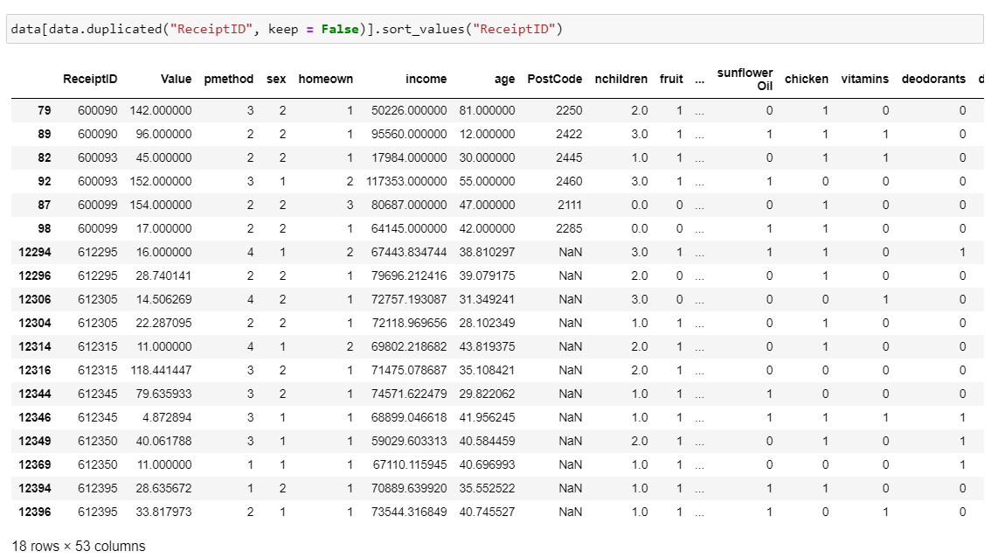

## Appendix V – Value

**Before cleaning**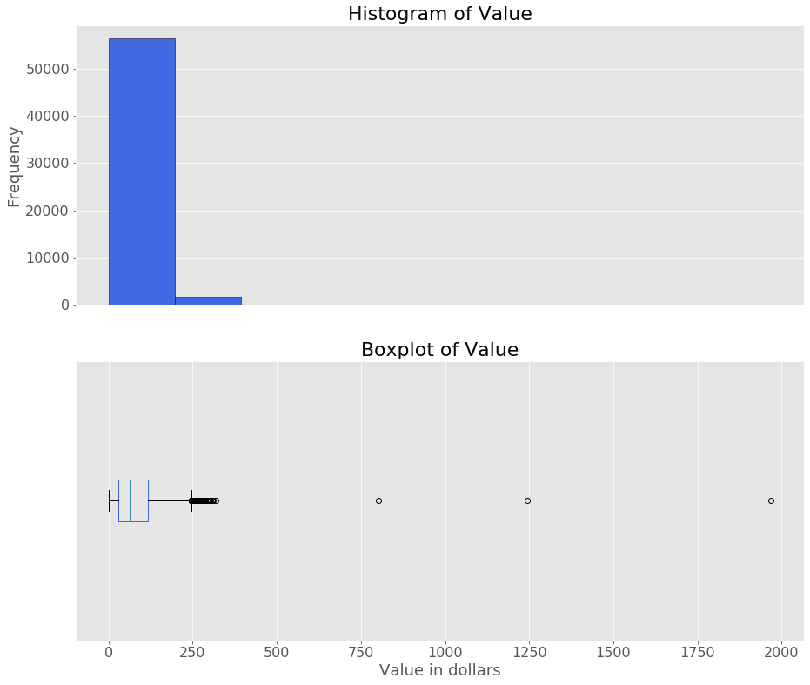

**After cleaning**

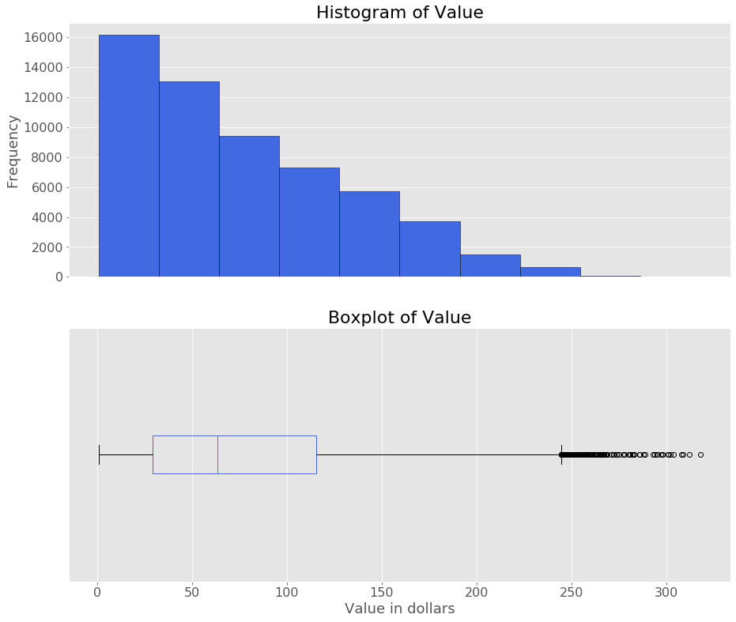

**Summary of Value Male VS Female Value**

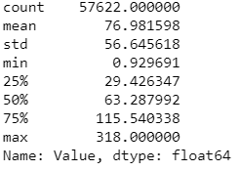 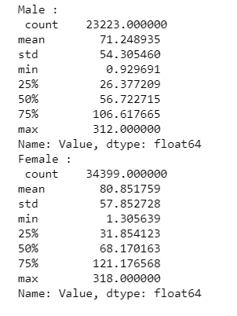

## Appendix VI – pmethod

**Before cleaning**

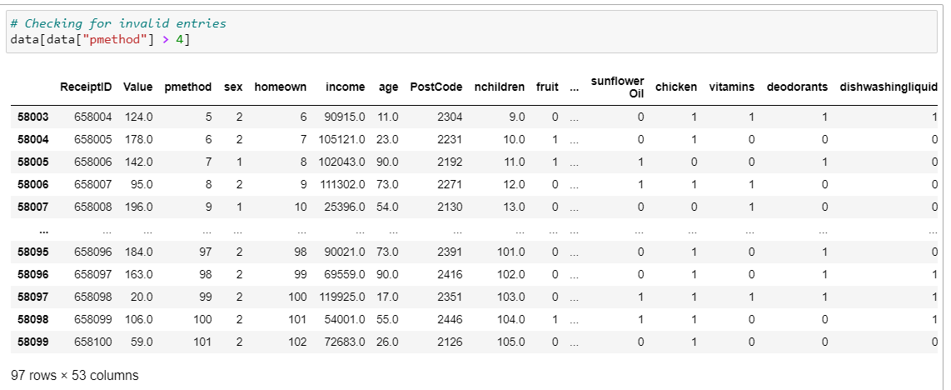

**After Cleaning**

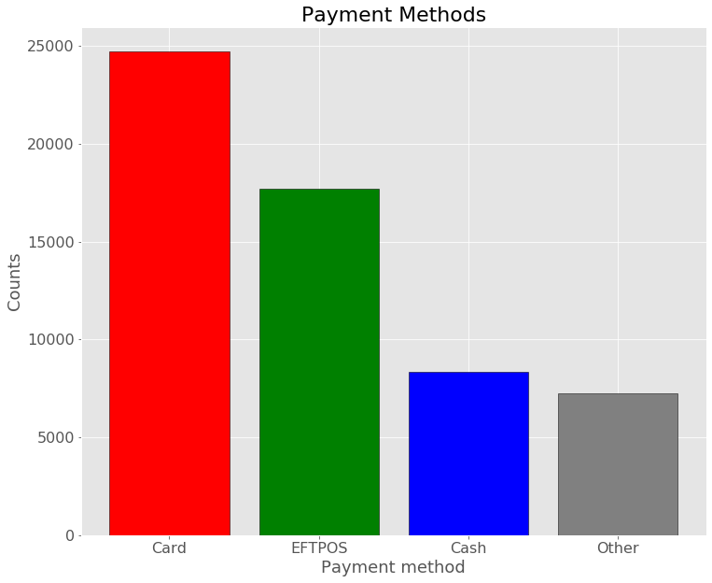

## Appendix VII – sex

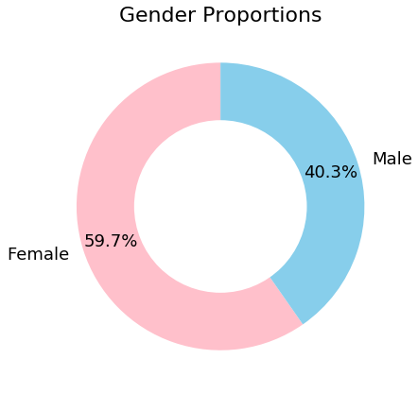

## Appendix VIII – homeown

**Before cleaning**

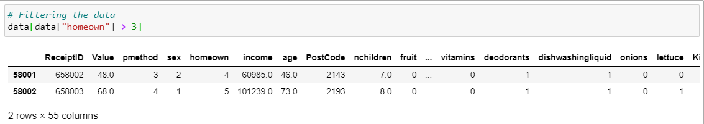

**After cleaning**

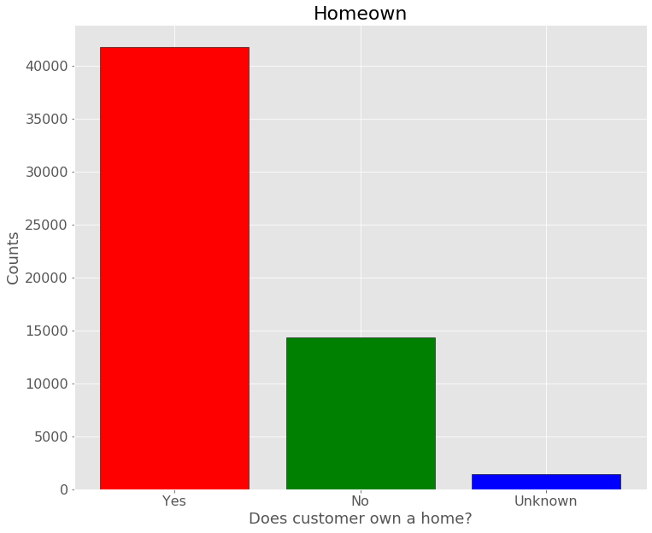

**Value for Homeowners VS Not Homeowners**

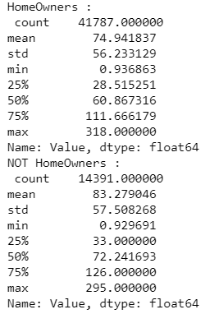

## Appendix IX – income

**Before cleaning**

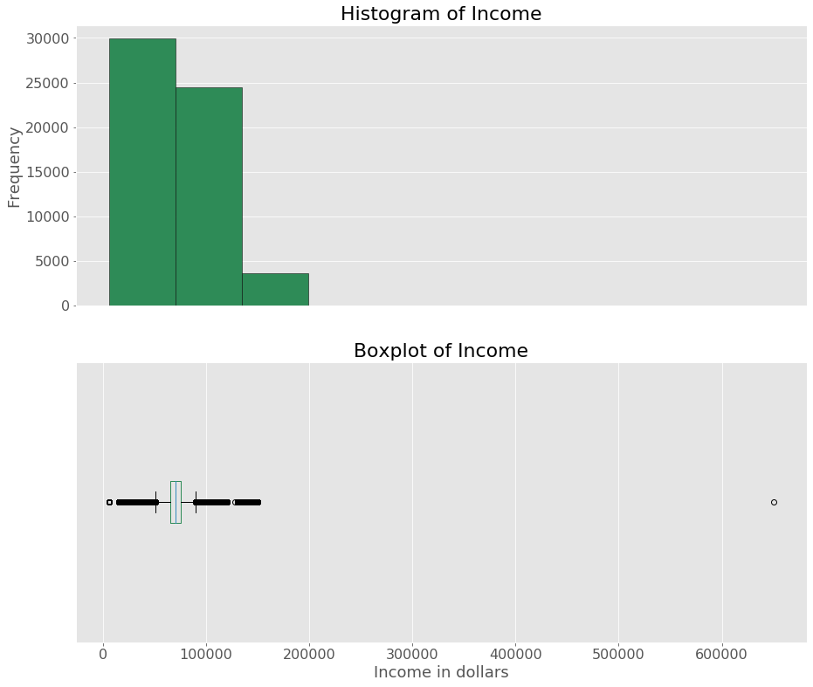

**After cleaning**

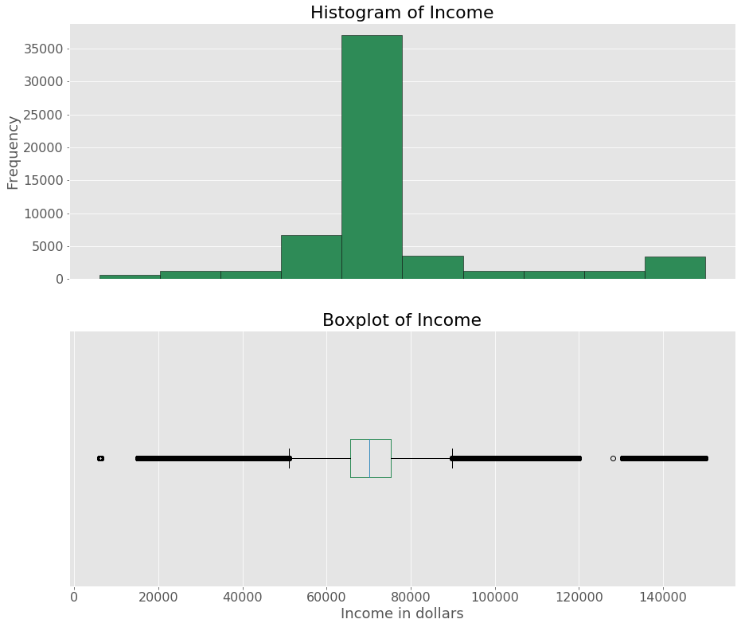

## Appendix X – age

**Before cleaning**

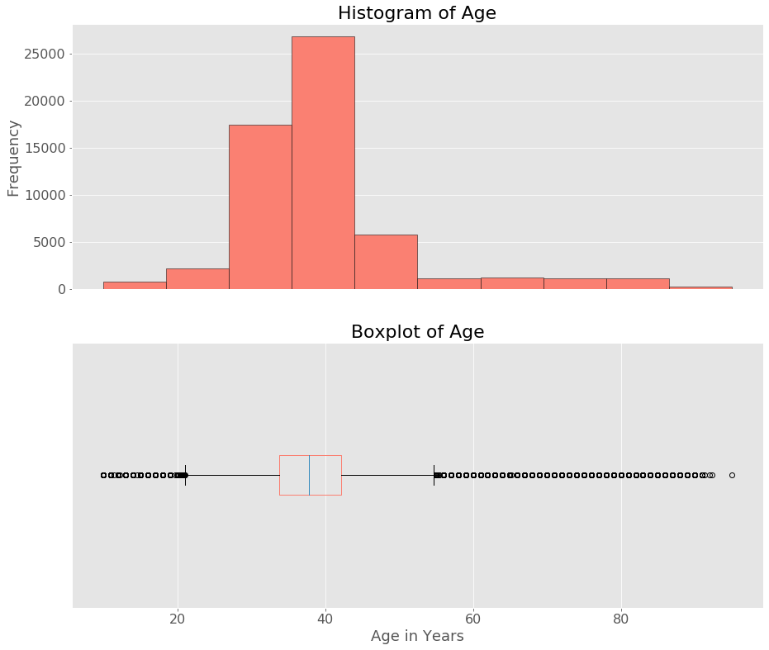

**After cleaning**

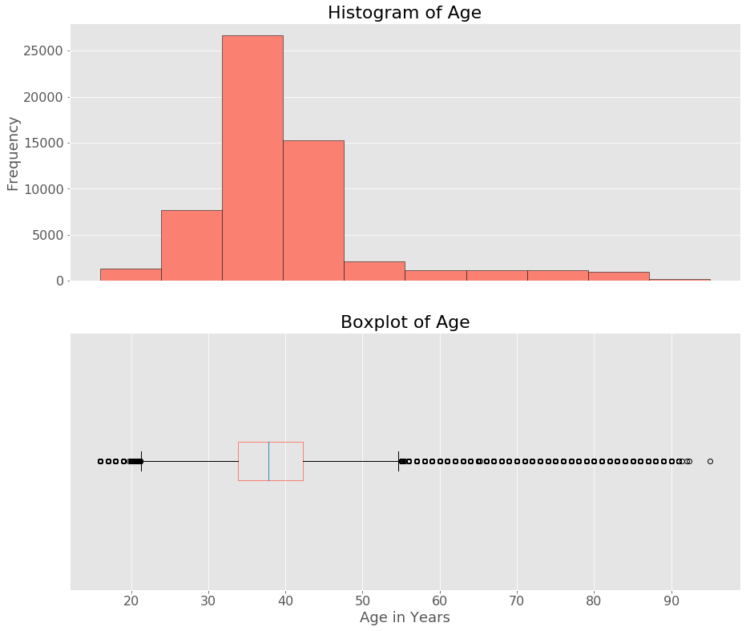

Appendix XI – nchildren

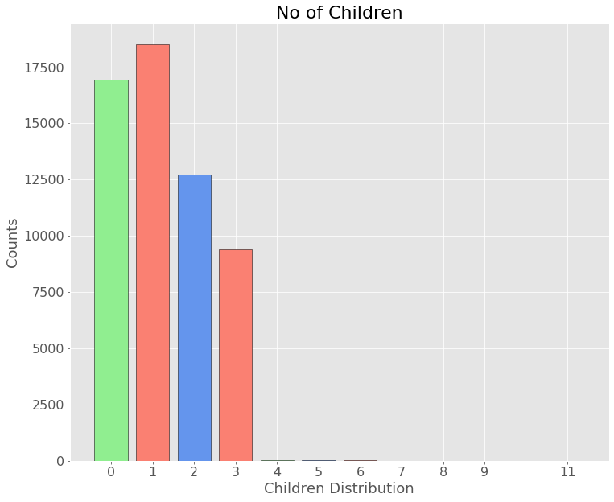

## Appendix XII – parent

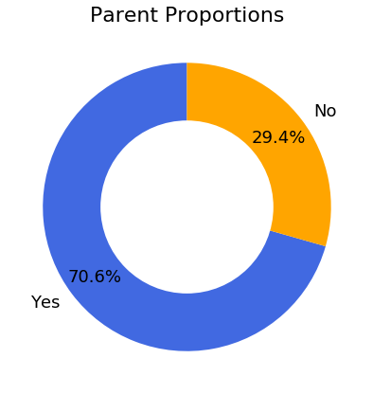

## Appendix XIII – Pet Owner

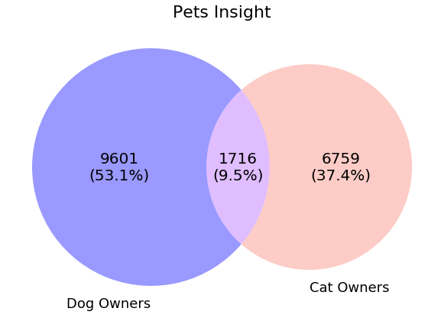

## Appendix XIV – Basket items

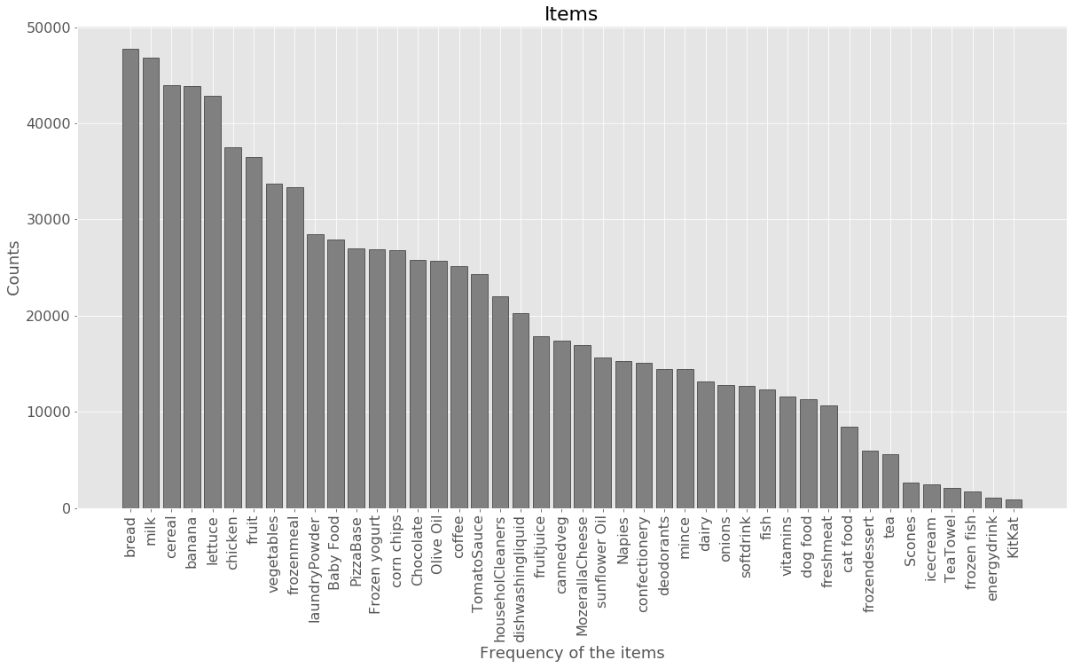

## Appendix XV – Summary for Numerical Variable

|  |  |  |  |  |  |  |  |
| --- | --- | --- | --- | --- | --- | --- | --- |
| **Variable** | **Min** | **25%** | **50%** | **75%** | **Max** | **Mean** | **Std.Dev** |
| ***Value(in $)*** | 0.92 | 29.43 | 63.29 | 115.54 | 318.00 | 76.98 | 56.64 |
| ***income(in $)*** | 6000.23 | 65,623.48 | 70,170.42 | 75324.32 | 149981.00 | 74884.04 | 23761.12 |
| ***age(in years)*** | 16 | 33.84 | 37.83 | 42.24 | 95 | 39.87 | 11.40 |

## Appendix XVI – Summary for Categorical Variable

|  |  |
| --- | --- |
| **Variable** | **Frequency – Percentage** |
| ***pmethod*** | 1 = Cash - 24,488 – 42.5%  3 = Eftpos – 17,575 – 30.5%  2= Card – 8,310 – 14.4%  4 = Other – 7,249- 12.6% |
| ***sex*** | 2 = Female – 34,399 – 59.7%  1 = Male – 23,223 – 40.3% |
| ***homeown*** | 1 = Yes – 41,787 – 72.5%  2 = No – 14,391 – 25%  3 = Unknown – 1,444 – 2.5% |
| ***parent*** | Yes – 40,683 – 70.6%  No – 16,939 – 29.4% |
| ***Pet Owner*** | No – 39,546 – 68.6%  Yes – 18,076 – 31.4% |
| ***nchildren*** | 1 = 18,519 – 32%  0 = 16,939 – 29%  2 = 12,712 – 22%  3 = 9,403 – 16%  4, 5, 6, 7, 8, 9, 11 = 49 ~= 1.1% |

## Appendix XVII – Income dominating the cluster results

1. **Income VS Value**

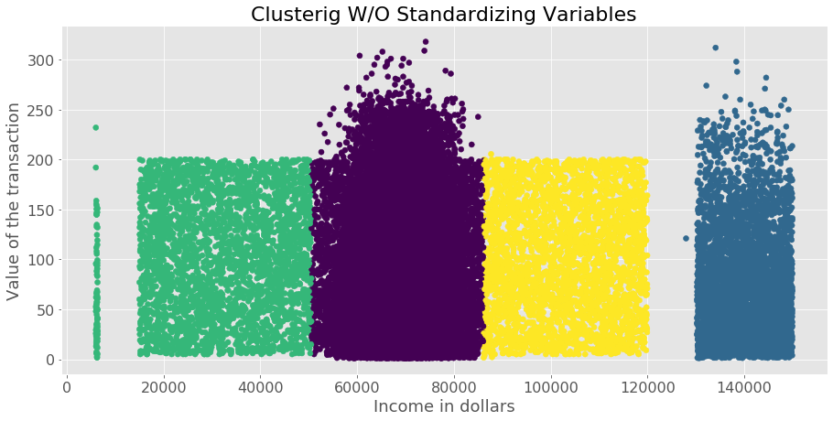

1. **Income VS Age**

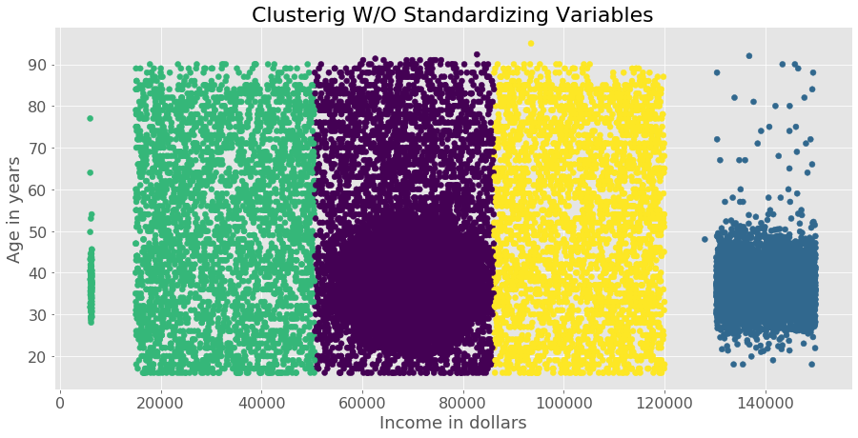

## Appendix XVIII – Cluster Size

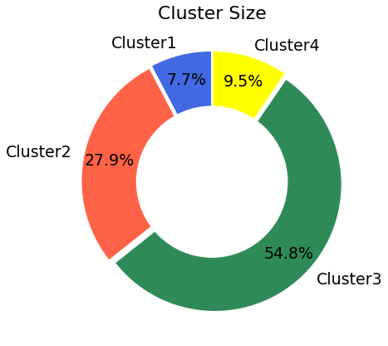

## Appendix XIX – Number of Children across clusters

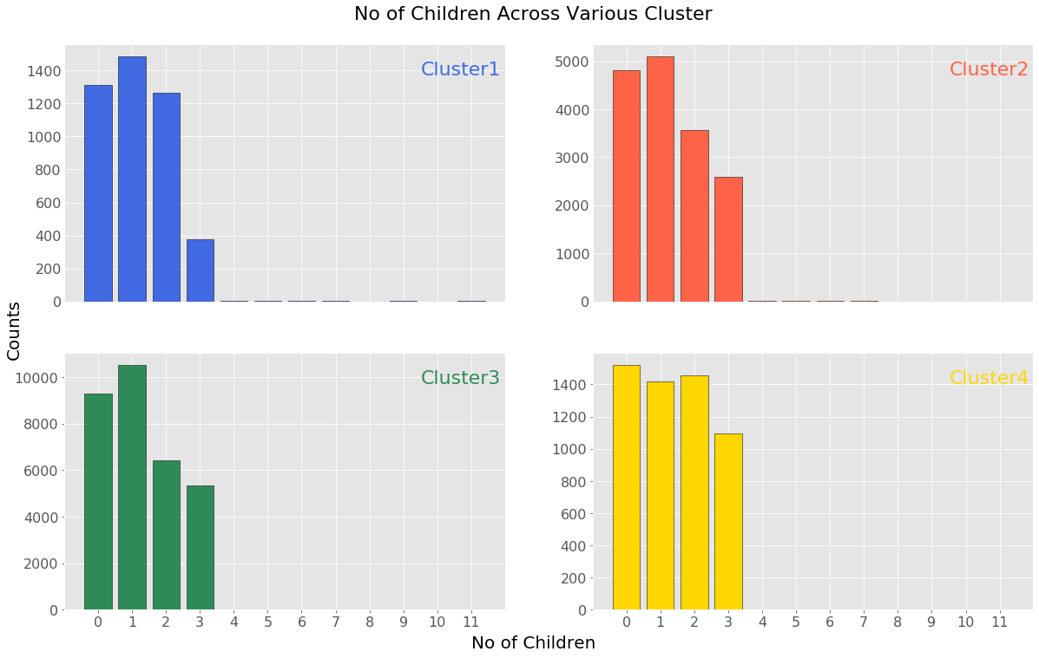

## Appendix XX – Income across clusters

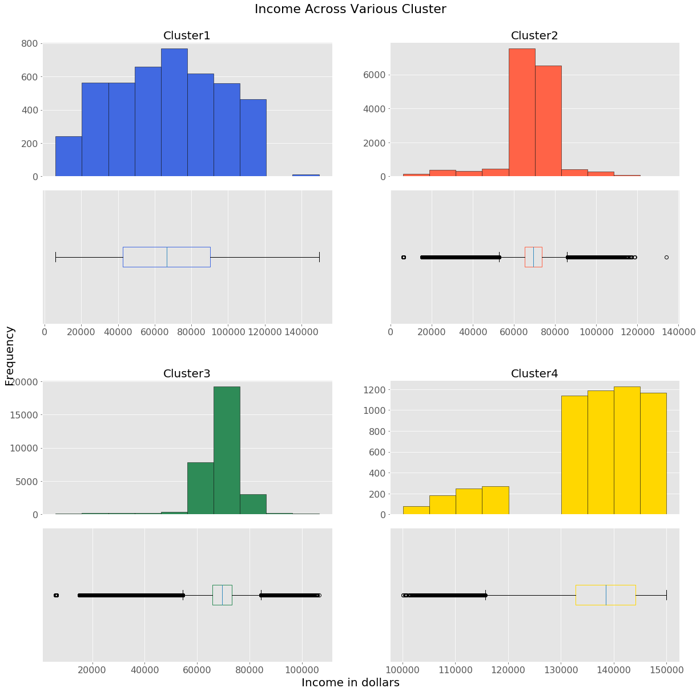

## Appendix XXI – Value across clusters

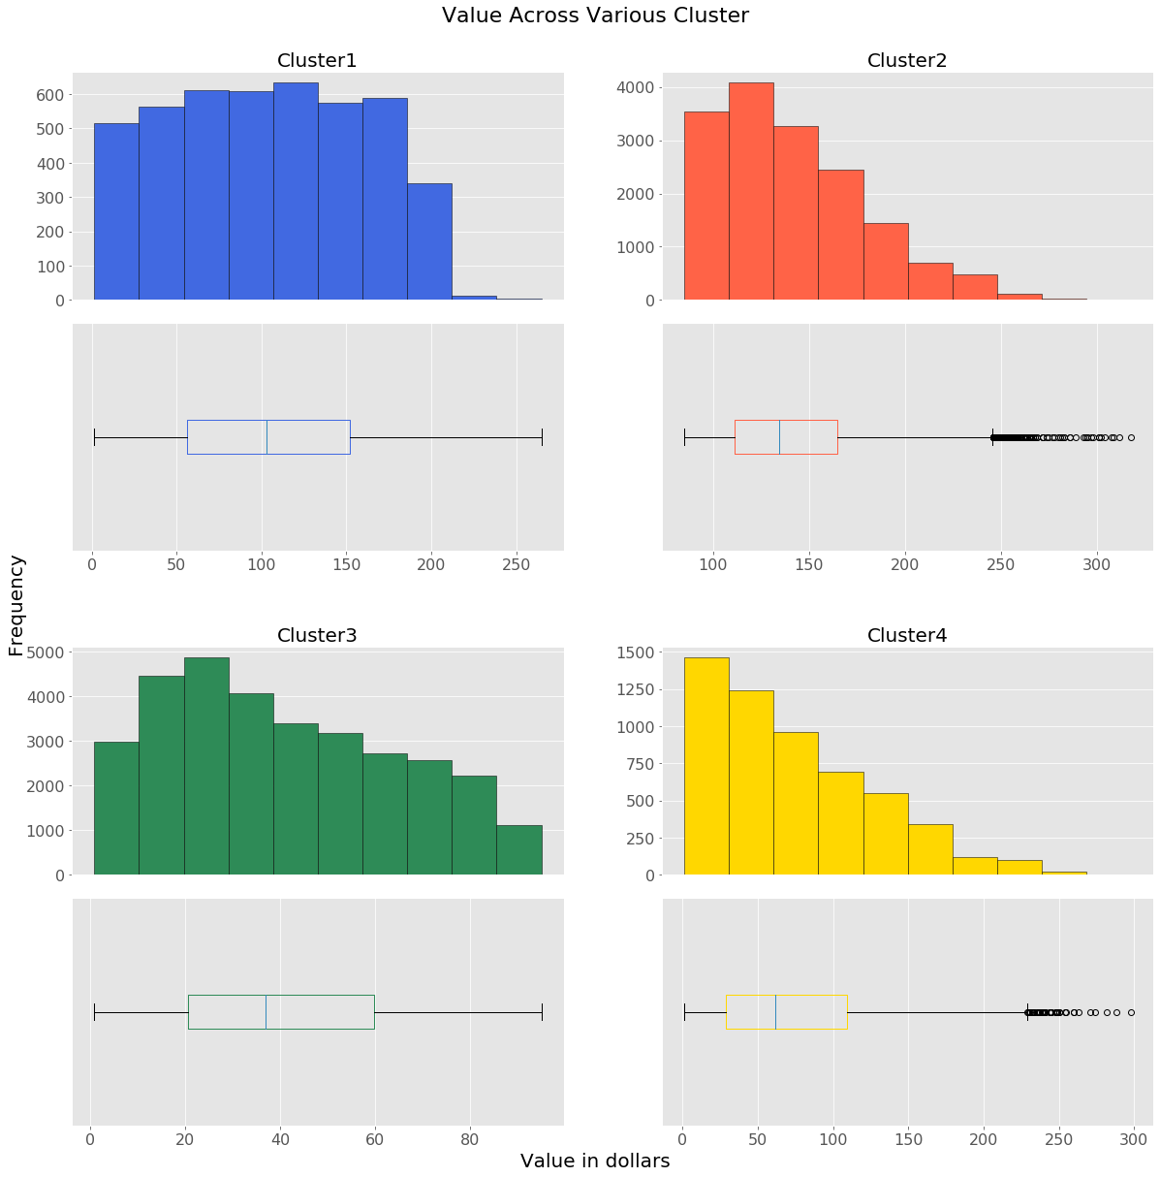

## Appendix XXII – Age across clusters

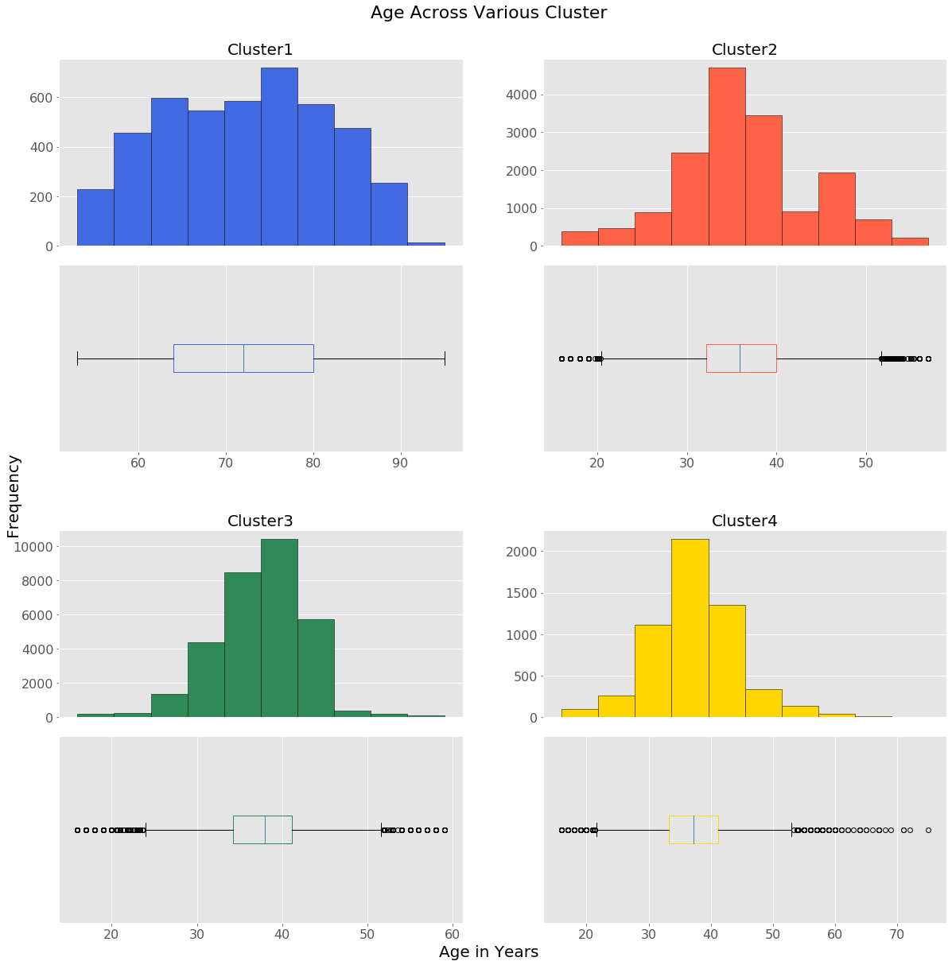

## Appendix XXIII – Gender Insights across clusters

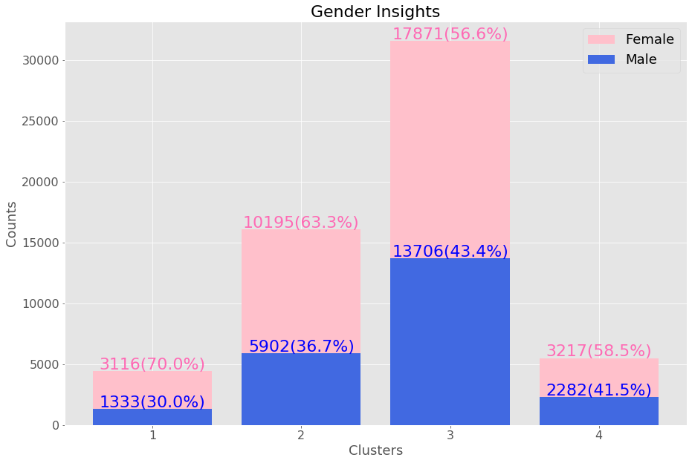

## Appendix XXIV – Payment Methods across clusters

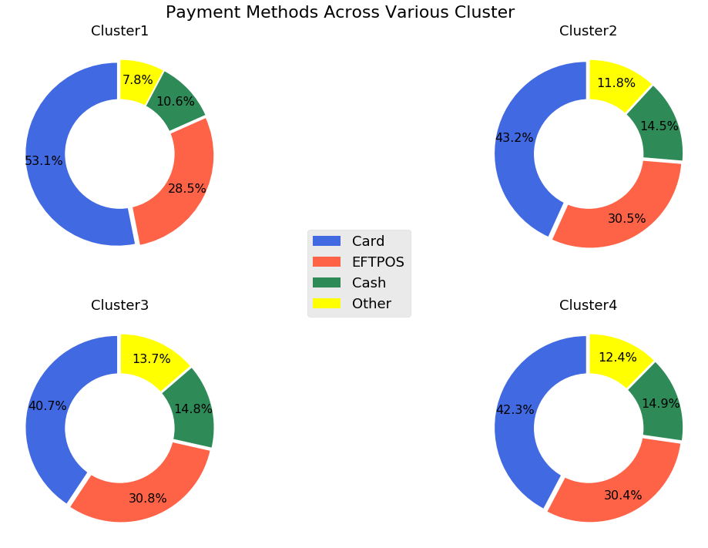

## Appendix XXV – Parents Insights across clusters

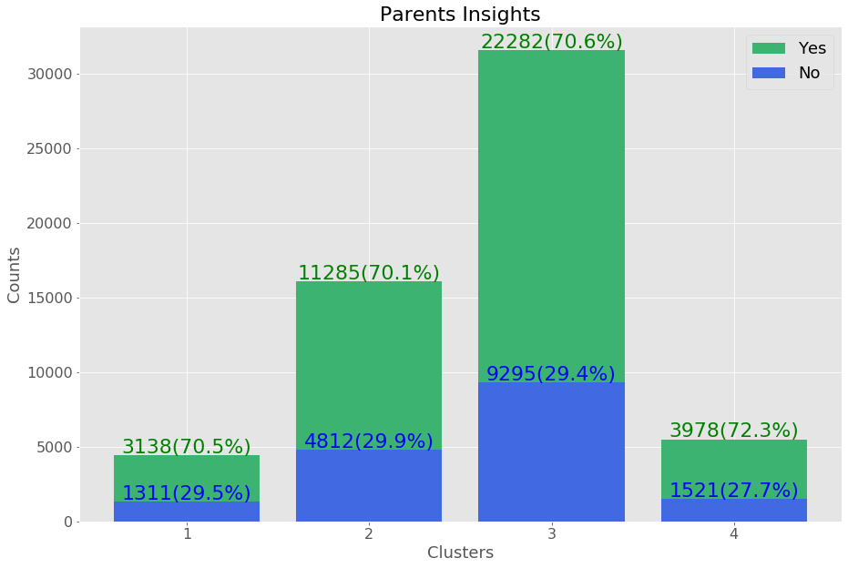

## Appendix XXVI – Homeown across clusters

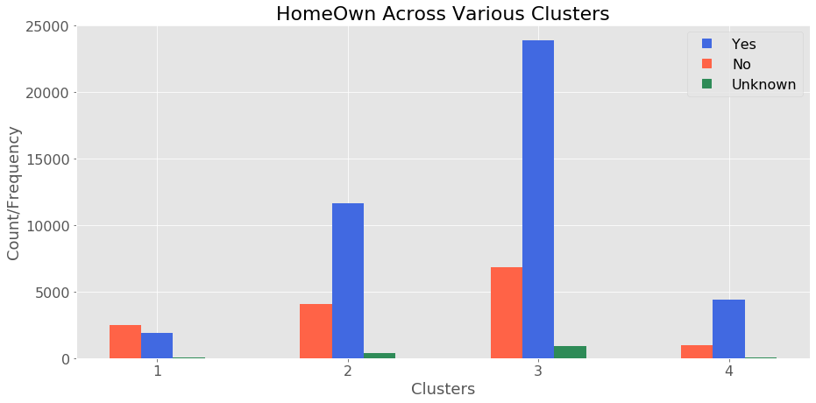

## Appendix XXVII – Pet Owner across clusters

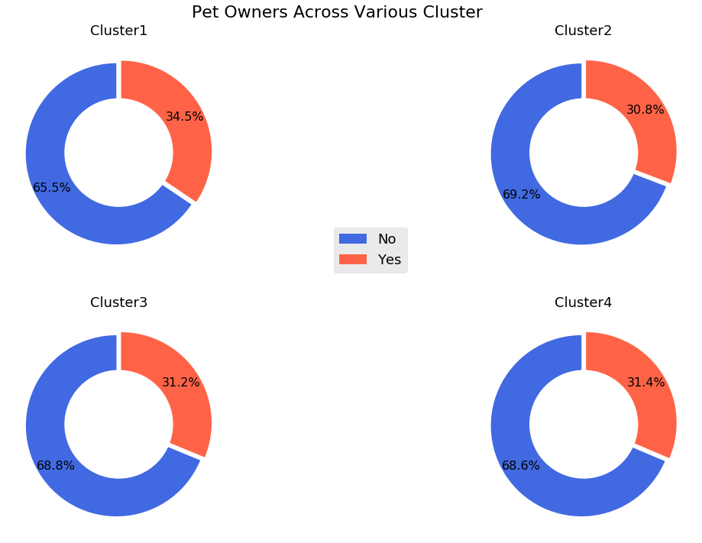

## Appendix XXVIII – Pet Insight across clusters

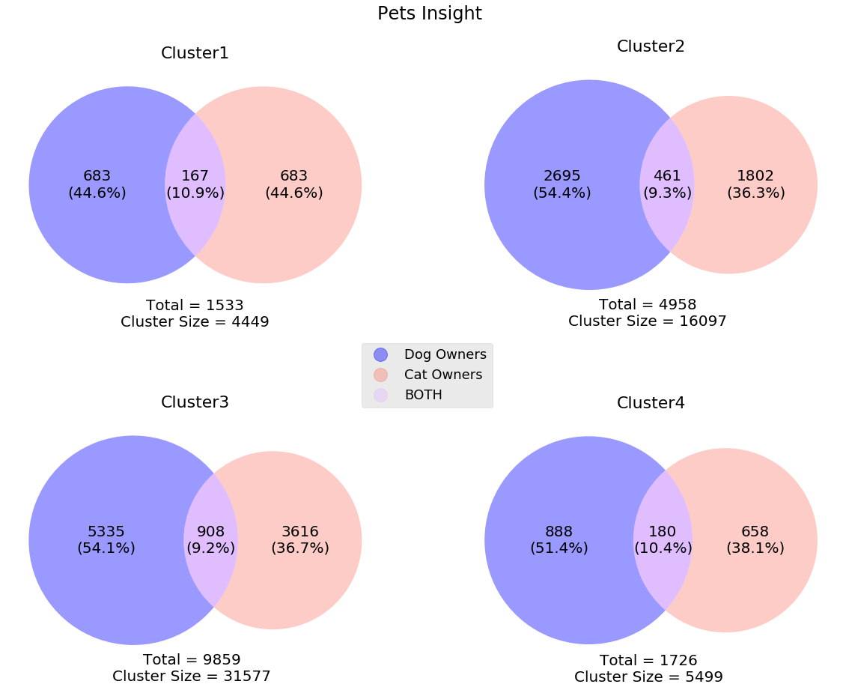

## Appendix XXIX – 3D(Income, age & Value) Scatter plot

